EXPERIMENT NO. 8
Student Counselling System using Zoho Creator (SaaS)

Aim
To develop a cloud-based Student Counselling System using Zoho Creator for managing student counselling details.

Objective
Create a SaaS application, store student details, display eligibility alerts, and generate reports.

Software Requirements
Zoho Creator, Deluge Script, Google Chrome, Internet Connection.

Theory
The Student Counselling System is a cloud-based application that stores student details such as name, age, address, phone number, subjects studied, year of passing, percentage of marks, and domain interest. Zoho Creator provides SaaS functionality for data storage and reporting.

Fields Used
Student Name, Age, Address, Phone Number, Subjects Studied, Year of Passing, Percentage of Marks, Domain Interest, Counselling Status, Counsellor Name.

Algorithm
Start → Enter Student Details → Validate Eligibility → Display Alert → Save Record → Generate Report → View Record → Stop.

Procedure
1. Create the application.
2. Design the form.
3. Add required fields.
4. Add Deluge workflow.
5. Enter sample records.
6. Generate report.
7. Verify records.

Observation
Student records were successfully stored. Eligibility alerts were displayed correctly. Reports and individual record views worked as expected.

Result
The Student Counselling System was successfully developed using Zoho Creator.

Conclusion
The experiment demonstrated a SaaS-based counselling application using Zoho Creator.

Output Screenshots
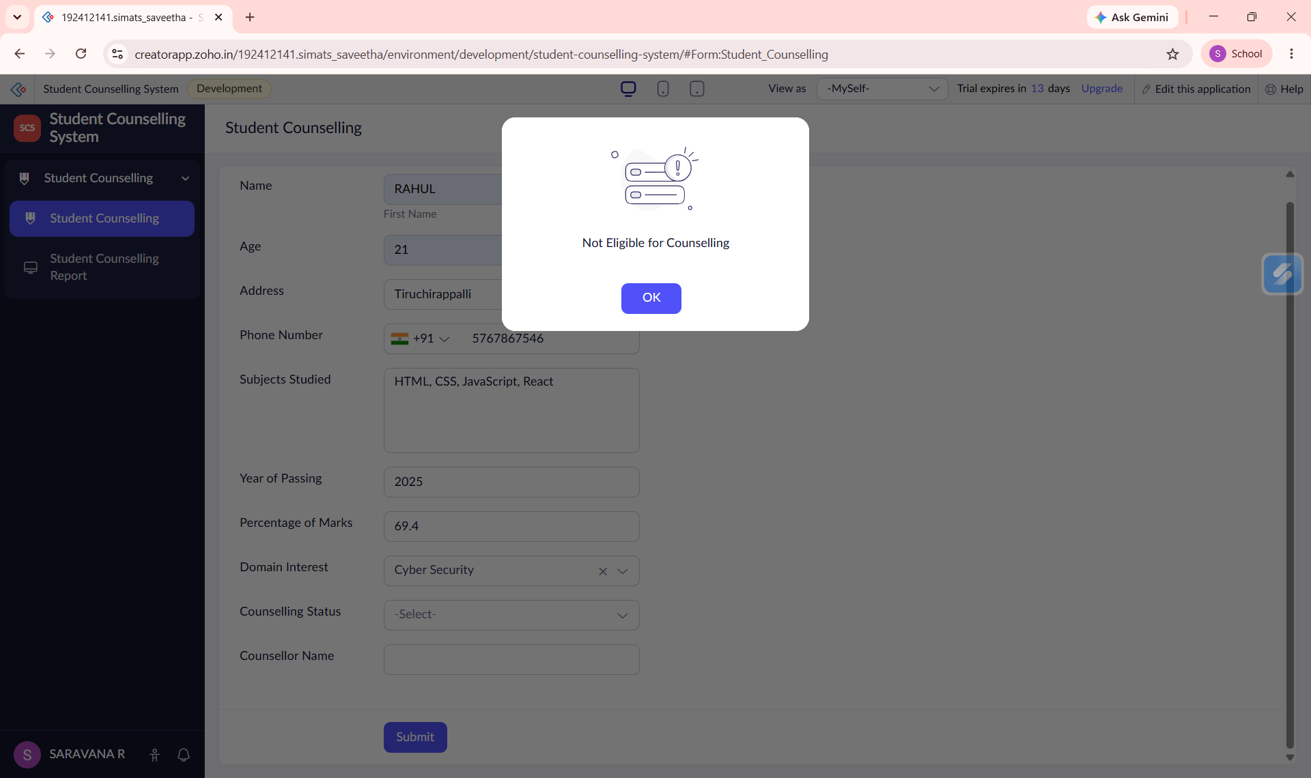
Figure 1: Eligibility Alert
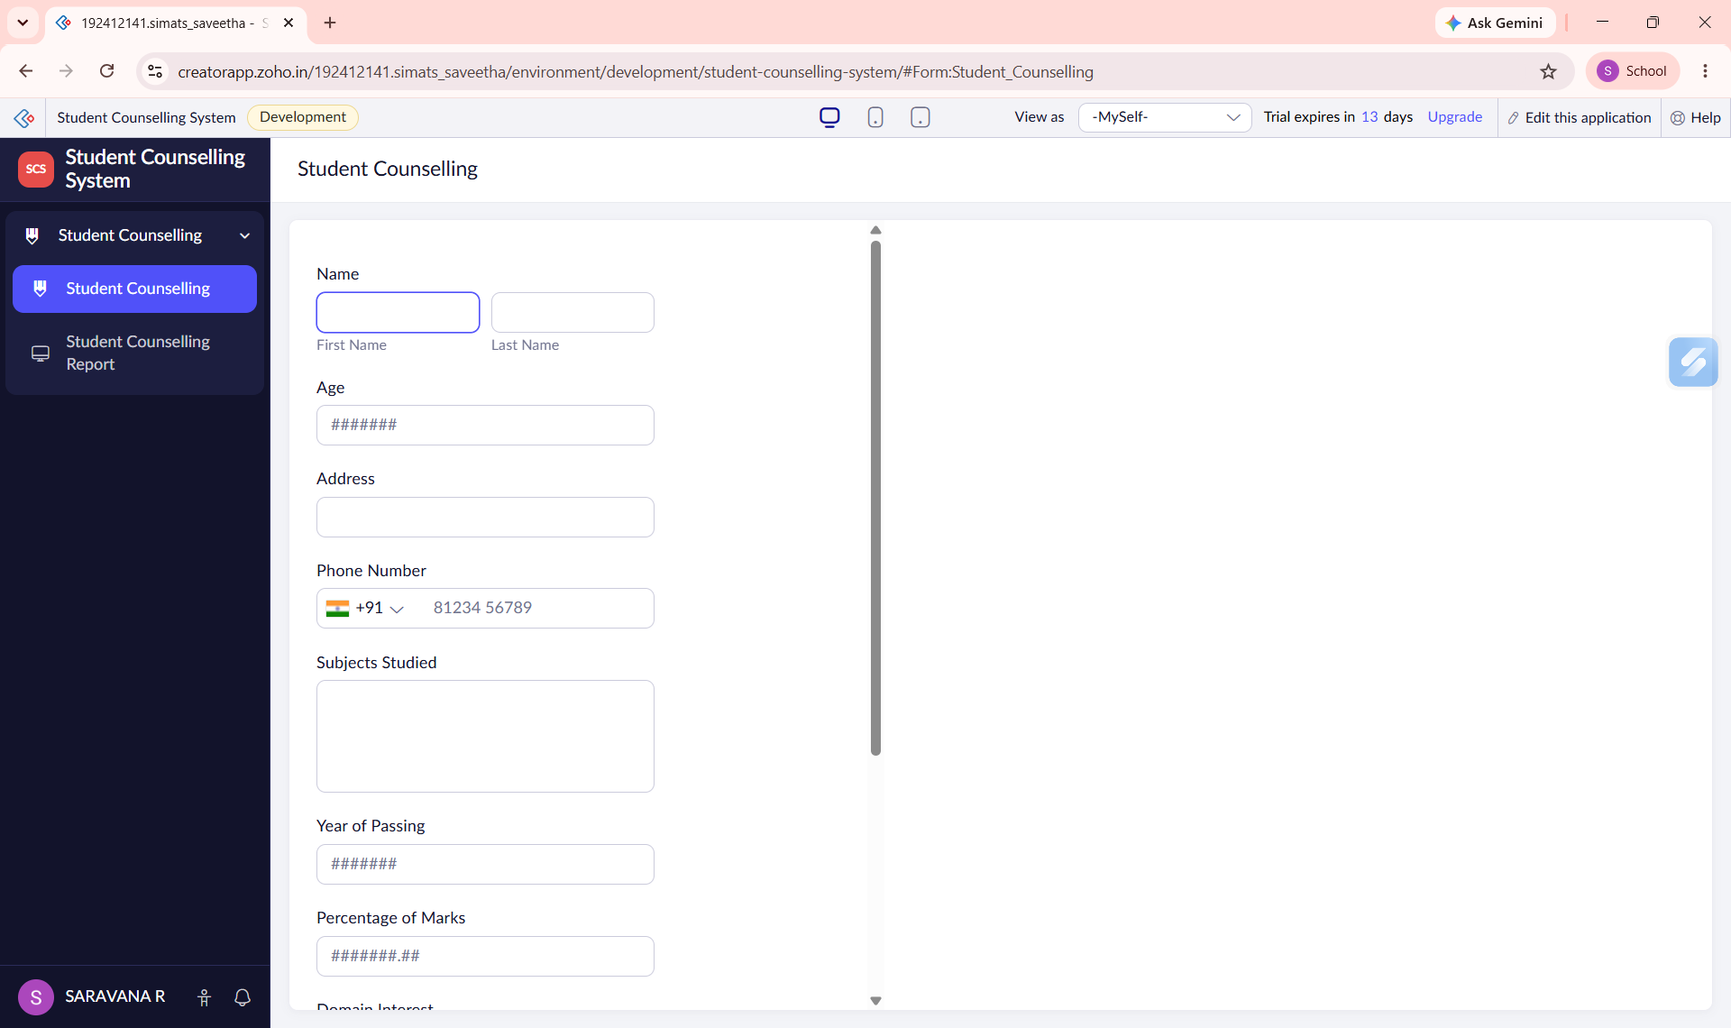
Figure 2: Student Counselling Form
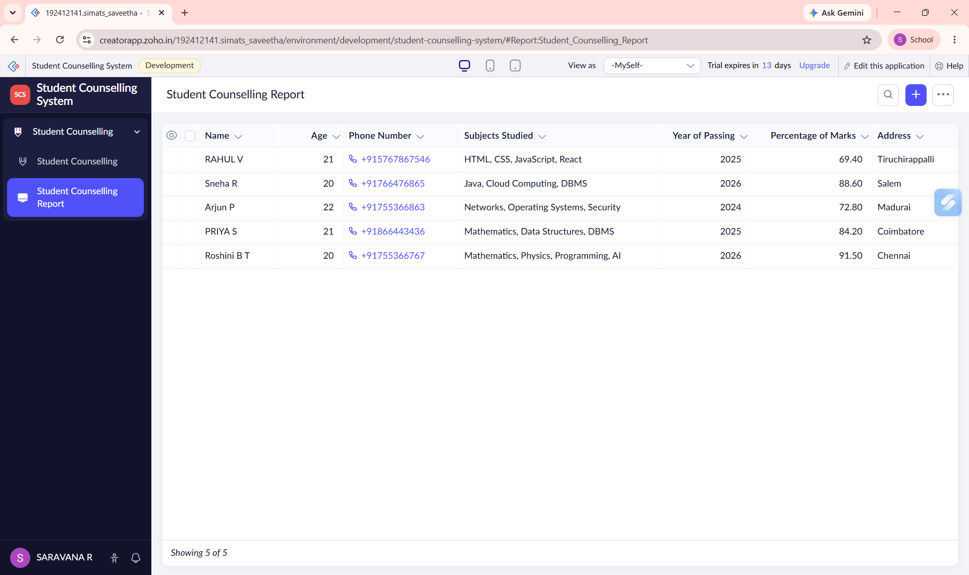
Figure 3: Student Counselling Report
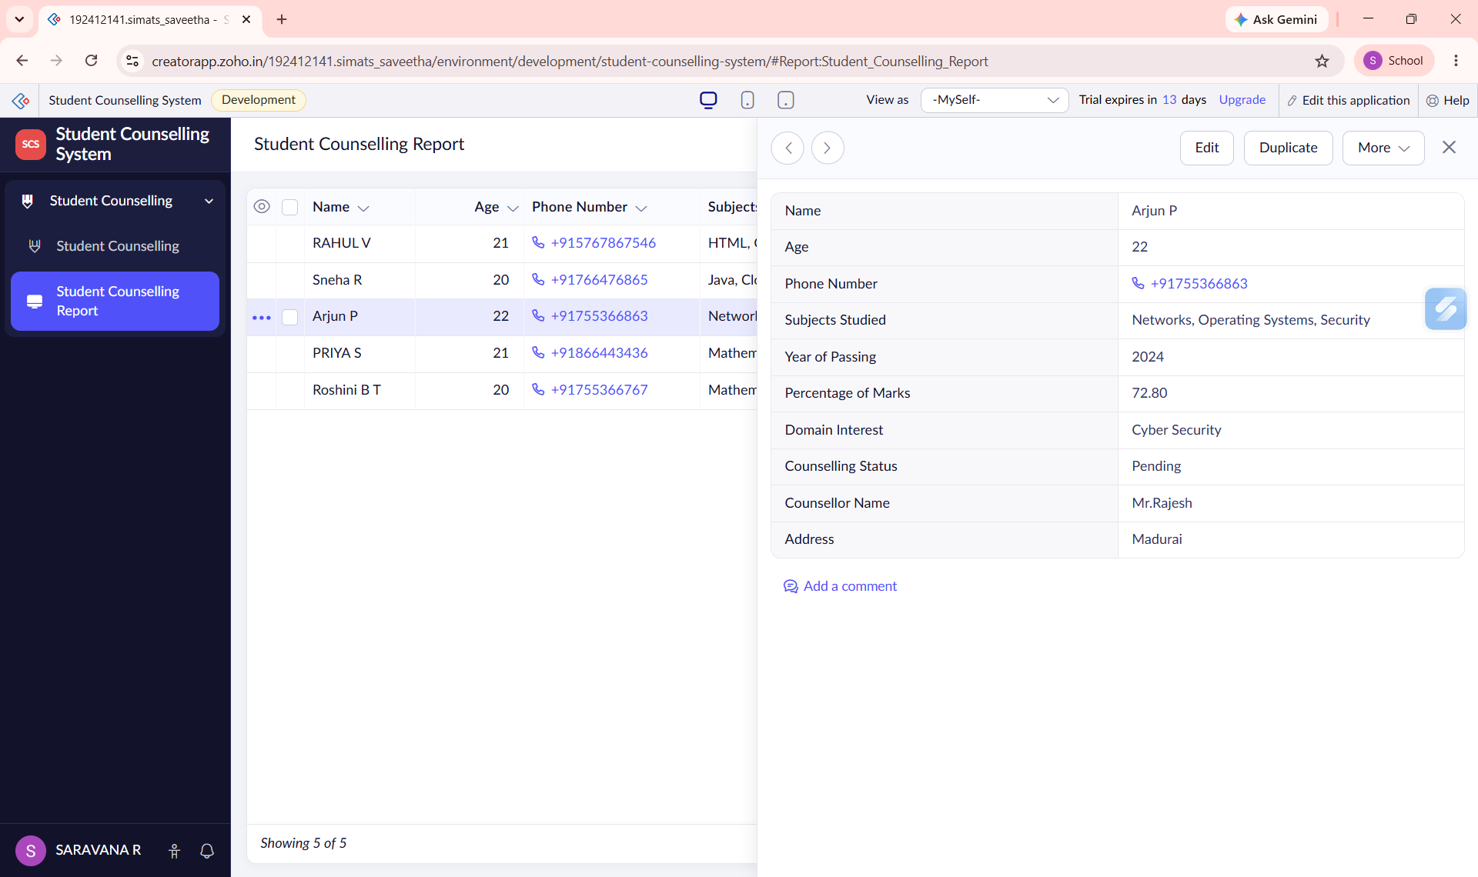
Figure 4: Individual Record View

